User Story-003

Testcase -002 : User should not find extra element in the home page

Step1: Navigate to the URL of the opencart site 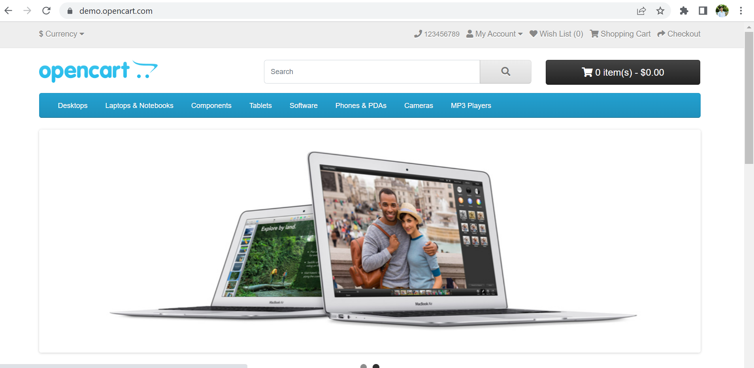

Step2: Search for the other entities which are present other than mentioned

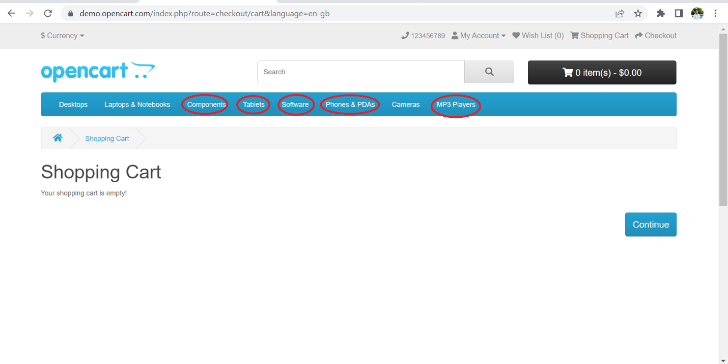

**All the steps are not passed and testcase-002 has a defect as its checkout button is navigating to shopping cart entity**